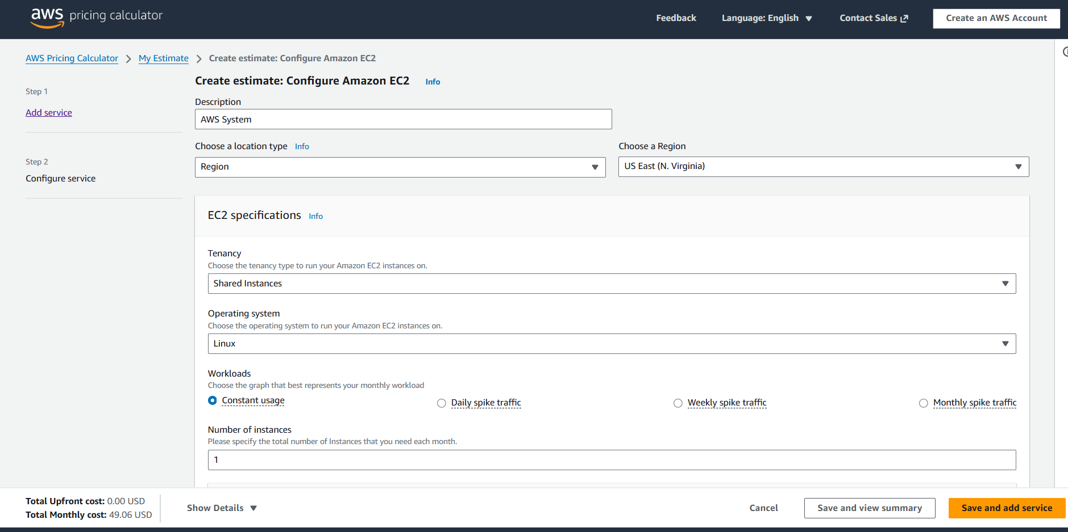

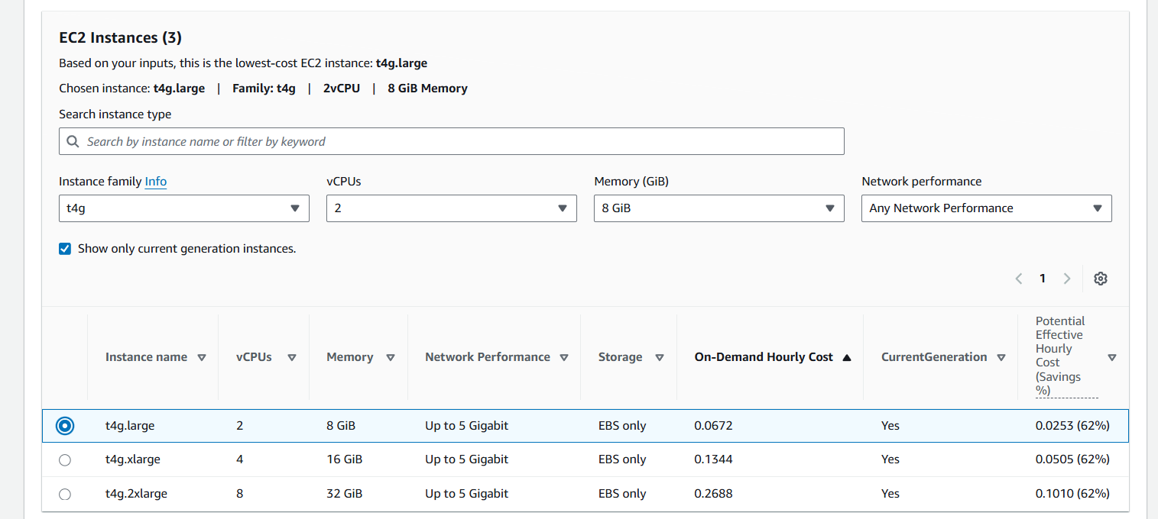

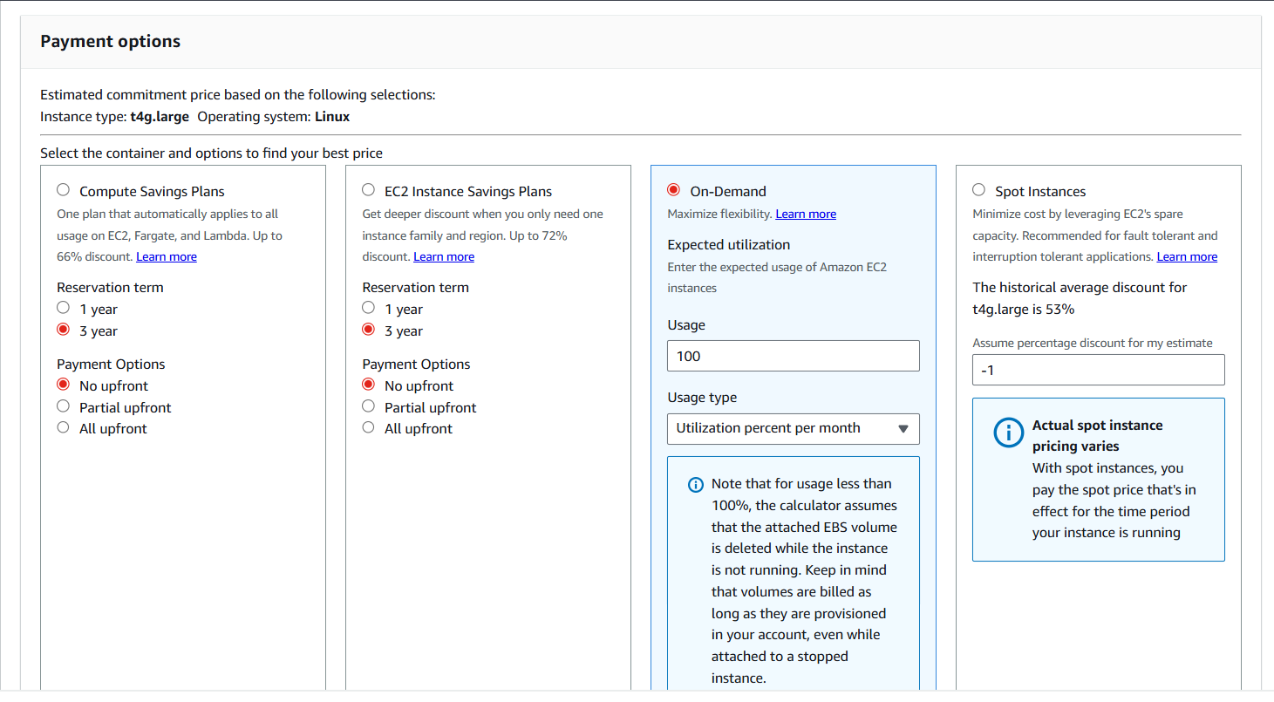
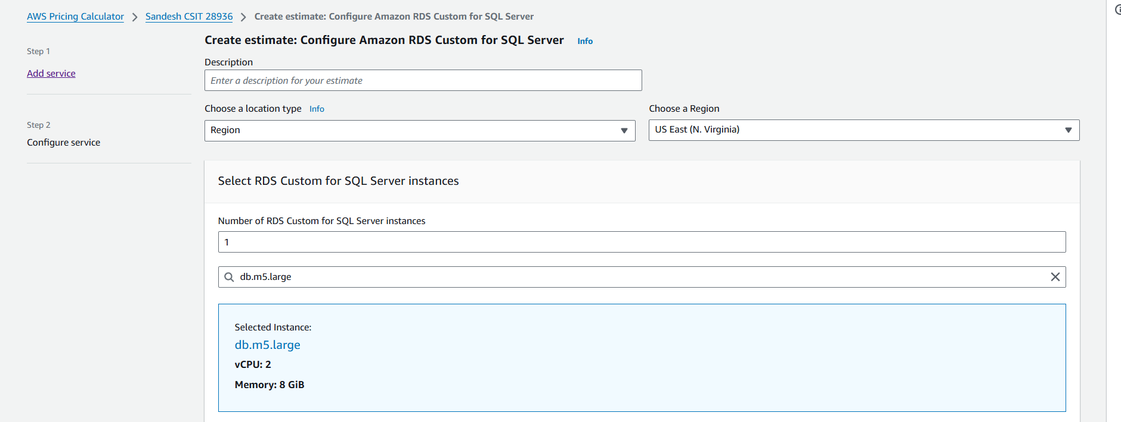
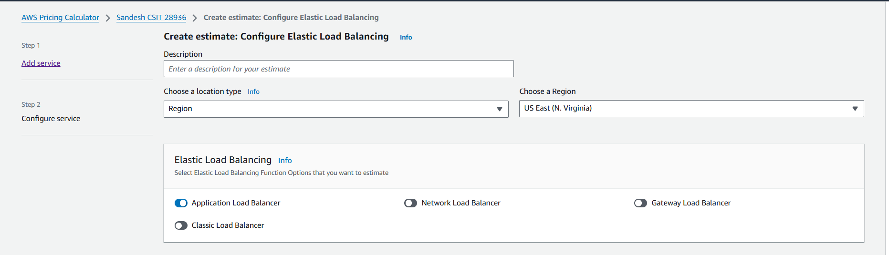
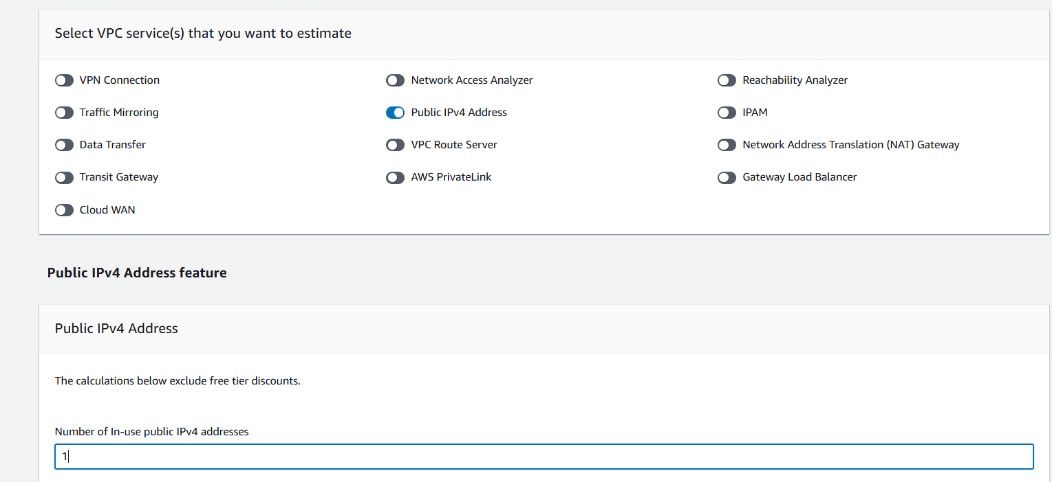
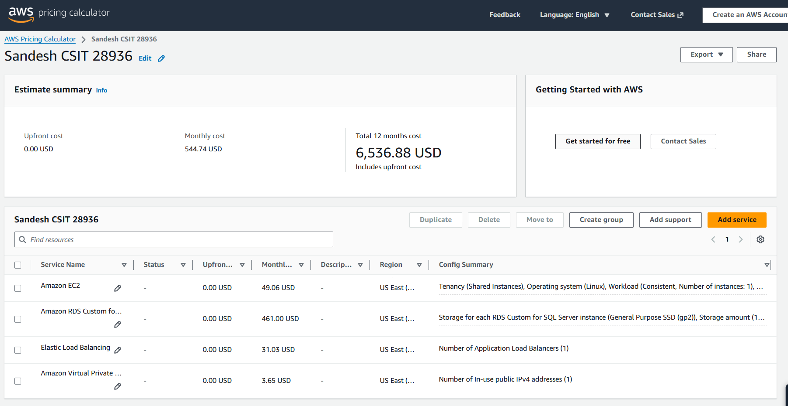

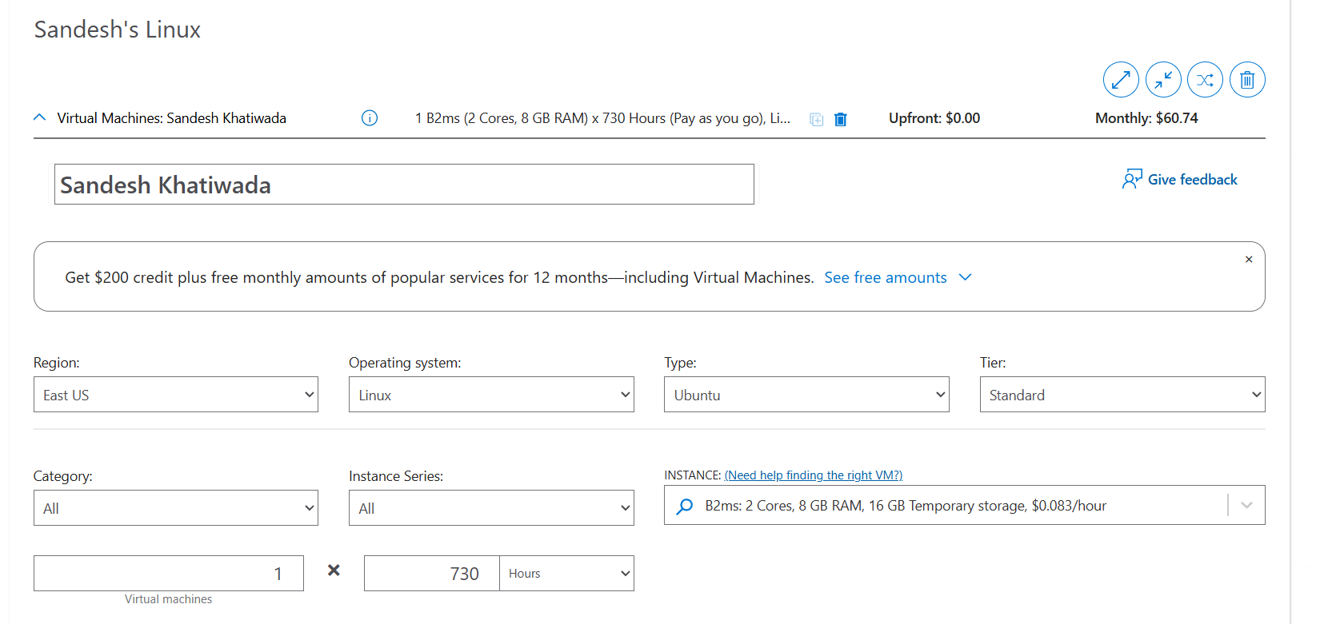
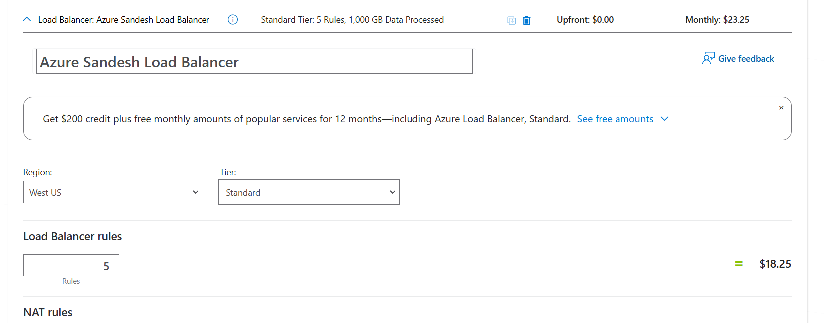
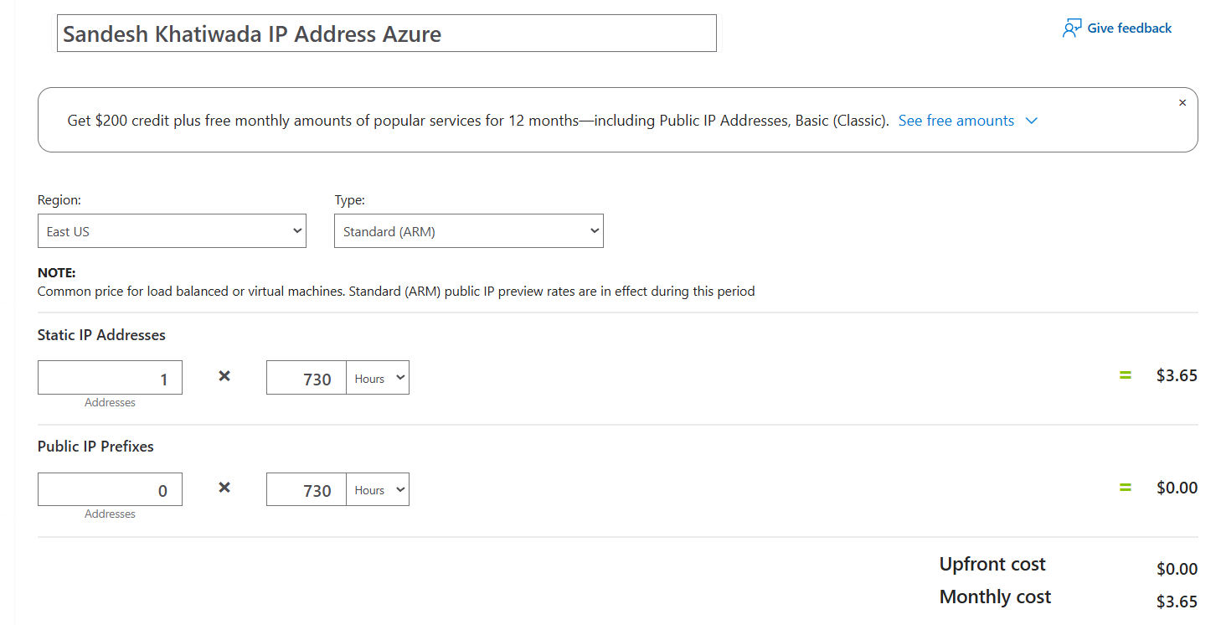
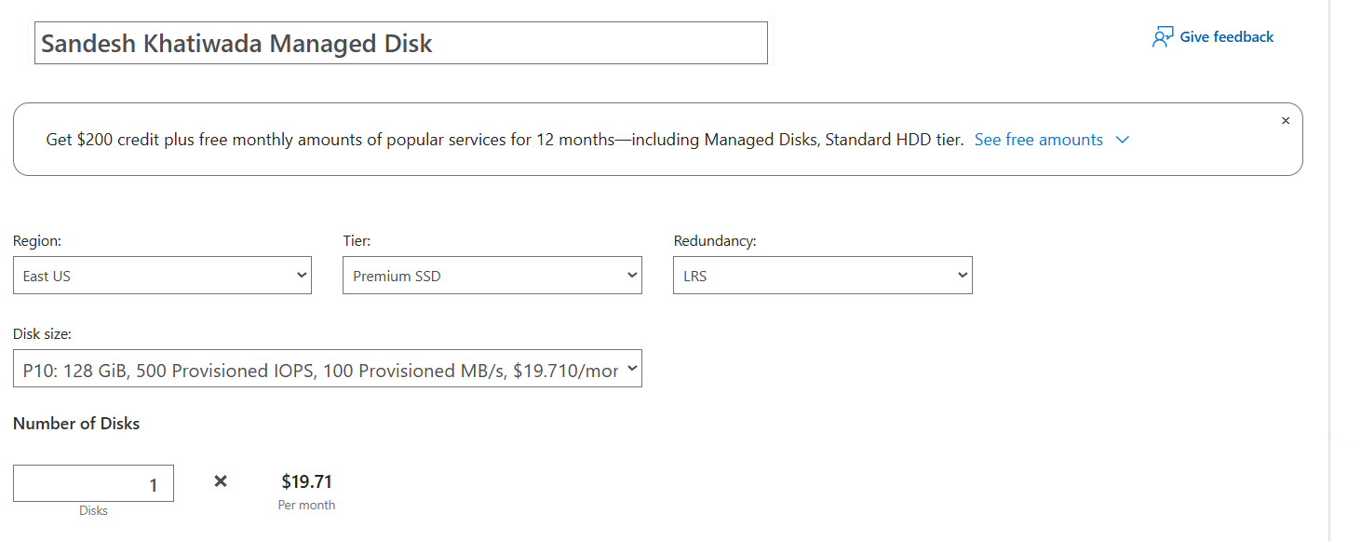
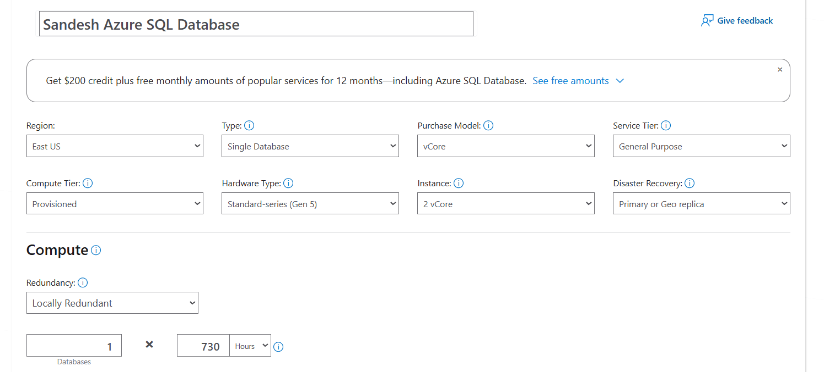
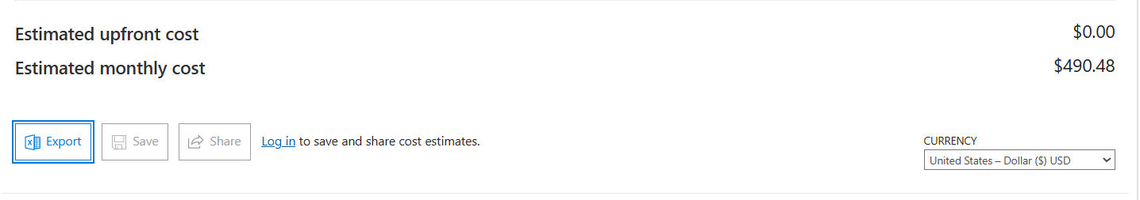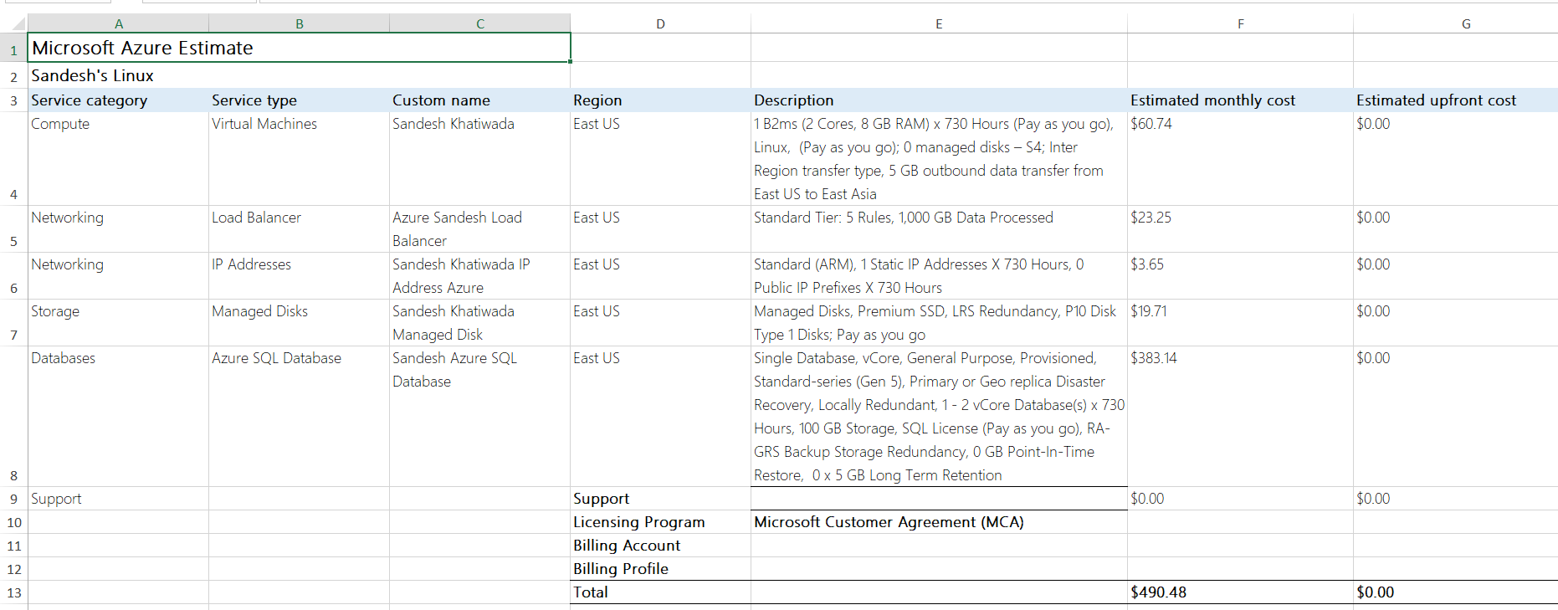

Conclusion
Azure is cheaper than AWS for this scenario.

Azure total: $490.48/month
AWS total: $544.74/month
Difference:

Azure is approximately $54.26 less per month than AWS for fully equivalent resources and region.
Biggest impact comes from:

Managed SQL database (Azure’s option is less expensive than AWS RDS for SQL Server).
VM and storage costs are similar; other line items make only a minor difference.
Summary Statement (for your lab report):
For the specified configuration—1 VM (2 vCPU, 8GB RAM), 100GB SSD, managed SQL database, load balancer, and static public IP in the US East region—Microsoft Azure is more cost-effective than AWS. The total estimated monthly cost on Azure is $490.48, while on AWS it is $544.74.
Azure provides an equivalent solution for about $54 less per month for this setup. This demonstrates the importance of pricing calculators and careful resource selection when planning cloud deployments.

